Module-1 Assignments

Assignment -1 :

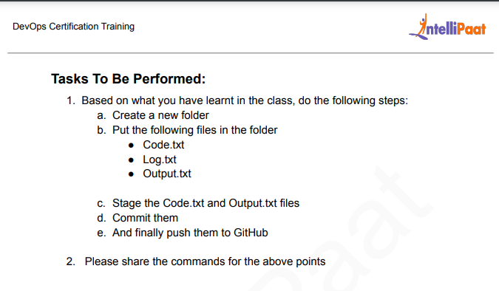

1 sudo apt-get update

2 git version

3 ls -la

4 mkdir project1

5 cd project1/

6 ls -la

7 vi code.txt

8 vi log.txt

9 rm -rf code.txt

10 rm -rf log.txt

11 git init

12 ls -la

13 nano code.txt

14 nano log.txt

15 nano output.txt

16 ls

17 git add code.txt

18 git add output.txt

19 git status

20 git commit -m "Codes Pushed"

21 git clone https://github.com/debasish467/devops-May-2024.git

22 git remote add origin https://github.com/debasish467/devops-May-2024.git

23 git push origin master

24 pwd

25 git push origin master

26 git remote add origin https://github.com/debasish467/git-assignments.git

27 git status

28 git remote rm origin

29 git remote add origin https://github.com/debasish467/git-assignments.git

30 git status

31 git log --oneline

32 git push origin master

Assignment -2:

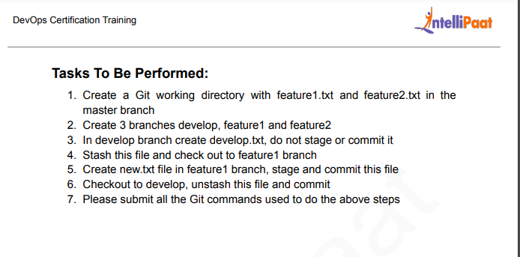

37 mkdir assignment 2

38 ls

39 mkdir assignment2

40 ls

41 rm -rf 2

42 ls

43 cd assigment2

44 cd assignment2

45 clear

46 git init

47 touch feature1

48 touch feature2

49 git add .

50 git commit -m "done"

51 git branch develop

52 git branch feature1

53 git branch feature2

54 git branch

55 git checkout develop

56 ls

57 touch develop.txt

58 ls

59 git stash -u

60 ls

61 ls -la

62 ls -l

63 ls -a

64 git branch

65 git checkout feature1

66 touch new.txt

67 ls

68 git add .

69 git commit -m "done"

70 git checkout develop

71 ls

72 git stash pop

73 ls

74 git add .

75 git commit -m "done2"

Assignment -3 :

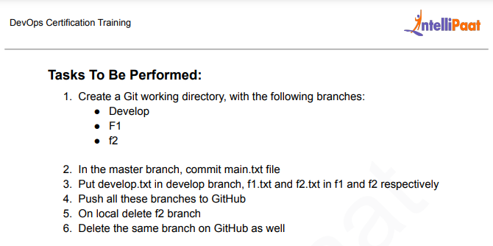

91 mkdir assignment3

92 cd assignment3

93 clear

94 git branch Develop

95 git init

96 git branch develop

97 git branch

98 touch main.txt

99 ls

100 git add .

101 git commit -m "code pushed"

102 git status

103 git branch

104 git branch Develop

105 git branch F1

106 git branch f2

107 git branch

108 git branch Develop

109 git checkout Develop

110 touch develop.txt

111 git checkout F1

112 touch f1.txt

113 git checkout f2

114 touch f2.txt

115 git remote add origin https://github.com/debasish467/Assigment3.git

116 git branch

117 git add .

118 git commit -m "done"

119 git remote add origin https://github.com/debasish467/Assigment3.git

120 git push origin --all

121 git branch

122 git checkout F1

123 git branch -D f2

124 git branch

125 git push origin -d f2

Assignment – 4:

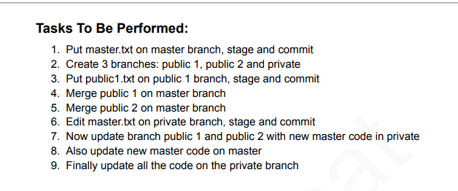

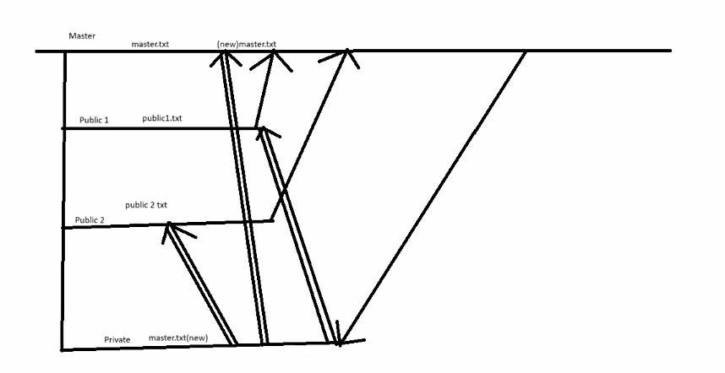

1 sudo apt-get update

2 mkdir assignment4

3 git init

4 touch master.txt

5 git add .

6 git commit -m "push"

7 git branch

8 ls

9 cd assignment4

10 touch master.txt

11 git add .

12 git commit -m "push"

13 git branch

14 git branch public1

15 git braanch public2

16 git branch public2

17 git branch private

18 git checkout public1

19 git branch

20 touch public1.txt

21 git add .

22 git commit -m "public1 done"

23 git checkout public2

24 touch public2.txt

25 git add .

26 git commit -m "public2 done

27 git commit -m "public2 done"

28 git checkout master

29 ls

30 git merge public1

31 git merge public2

32 ls

33 git checkout private

34 ls

35 cat master.txt

36 nano master.txt

37 cat master.txt

38 git add .

39 git commit -m "private"

40 git checkout public1

41 ls

42 cat master.txt

43 git merge private

44 cat master.txt

45 git checkout master

46 cat master.txt

47 git checkout public2

48 cat master.txt

49 git merge private

50 cat master.txt

51 git checkout private

52 ls

53 git branch

54 git checkout master

55 git merge private

56 git checkout private

57 ls

58 git add .

59 git commit -m "push"

60 cat master.txt

61 git checkout private

62 git checkout master

63 ls

64 cat master.txt

65 git checkout private

66 ls

67 git merge master

68 ls

Assignment -5:

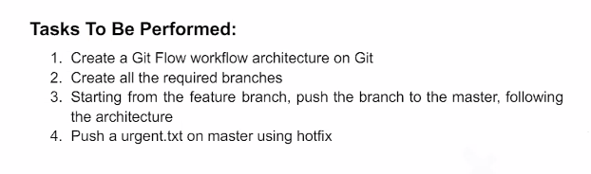

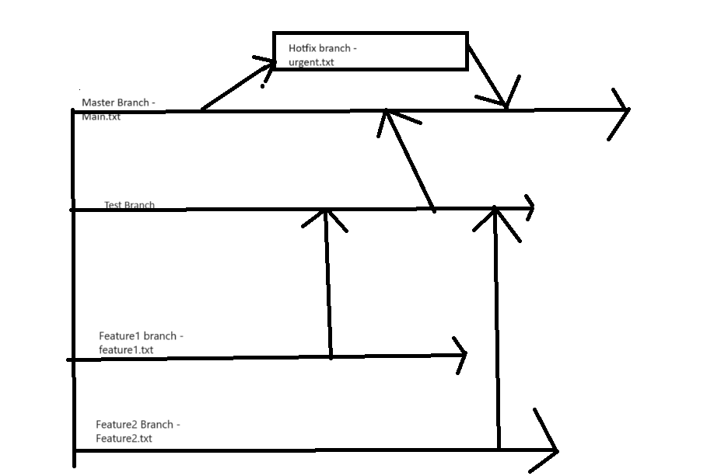

71 mkdir assignment5

72 cd assignment5

73 clear

74 git init

75 touch master.txt

76 git add .

77 git commit -m "push"

78 git branch

79 git branch test

80 git branch feature1

81 git branch feature2

82 git branch

83 git checkout feature1

84 touch feature1.txt

85 git add .

86 git commit -m "push"

87 git checkout feature2

88 touch feature2.txt

89 git add .

90 git commit -m "push"

91 git checkout test

92 git merge feature1

93 git merge feature2

94 git branch

95 ls

96 git checkout master

97 ls

98 git merge test

99 ls

100 git branch hotfix

101 git checkout hotfix

102 ls

103 touch hotfix.txt

104 git add .

105 git commit -m "push"

106 git branch

107 git checkout master

108 git merge hotfix

109 git branch master

110 git branch

111 ls

Case Study – 1 :

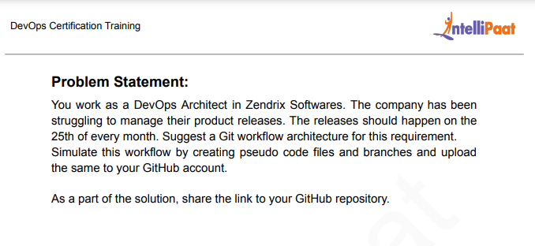

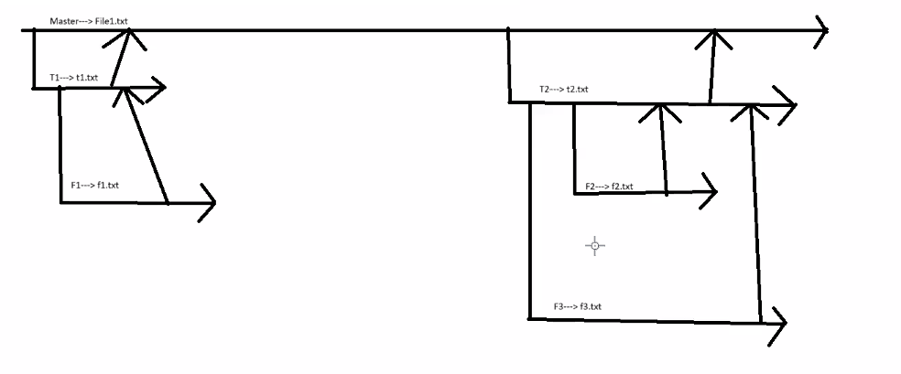

1 sudo apt-get update

2 mkdir cs1

3 cd cs1

4 git init

5 touch file1.txt

6 git add .

7 git commit -m "push"

8 git branch

9 git branch t1

10 git branch t2

11 git branch

12 git checkout t1

13 touch t1.txt

14 git add .

15 git commit -m "push"

16 git checkout t2

17 touch t2.txt

18 git add .

19 git commit -m "push"

20 git checkout t1

21 git checkout -b f1

22 git branch

23 touch f1.txt

24 git add .

25 git commit -m "push"

26 git checkout t2

27 git branch f2

28 git branch f3

29 git checkout f2

30 touch f2.txt

31 git add .

32 git commit -m "push"

33 git checkout f3

34 touch f3.txt

35 git add .

36 git commit -m "push"

37 git checkout t2

38 git merge f2

39 git merge f3

40 git checkout t1

41 git merge f1

42 git checkout master

43 ls

44 git merge t1

45 git merge t2

46 ls

47 git log --graph --oneline --decorate --all

48 git remote add origin https://github.com/debasish467/casestudy.git

49 git push origin –all

Case Study – 2 :

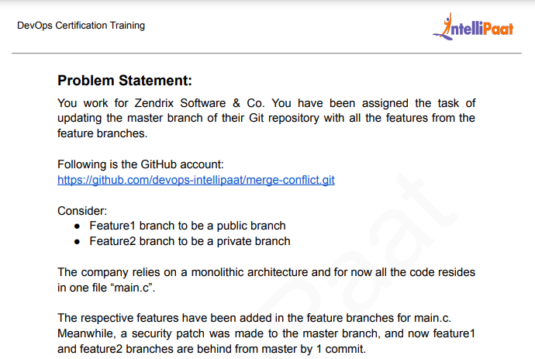

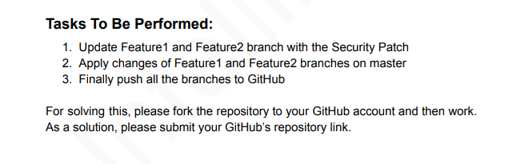

53 mkdir cs2

54 git init

55 git clone https://github.com/devops-intellipaat/merge-conflict.git

56 cd merge-conflict

57 ls

58 git branch

59 git checkout feature1

60 git checkout feature2

61 git branch

62 git checkout master

63 git merge feature1

64 git mergetool --help

65 git mergetool --tool=

66 git merge feature1

67 git add .

68 git commit -m "push"

69 git merge feature1

70 git checkout feature1

71 git branch

72 ls

73 git merge feature2

74 git mergetool --tool=

75 git add .

76 git commit -m "push"

77 git merge feature2

78 ls

